Year 12 Chemistry Semester 2 Exam 2003 Solutions

Part 1
1 c 11 b 21 a
2 c 12 c 22 d
3 a 13 b 23 c
4 d 14 c 24 b
5 c 15 c 25 d
6 b 16 b 26 d
7 c 17 c 27 c
8 d 18 b 28 b
9 a 19 a 29 a
10 d 20 b 30 d [60]

Part 2
1 (a)
white solid dissolves to form colourless solution [3]
(b)
(pale)blue ppt. formed [3]
(c)
colourless, odourless gas produced [3]
(d)
solution turns from colourless to orange/brown [3]
2
Description | Solution
Will have a pH of 2.0 | G
Will decolourise when added to C₂H₂ | F
Can oxidise bromide ions to bromine | C
Will form a precipitate when added to a solution of BaCl₂ | E
Will develop a red/brown colour when left in air | I
Can reduce Sn²⁺ to tin metal but not Mg²⁺ to magnesium metal | D
Contains a salt of a weak acid | E
Will go pink when a few drops of phenolphthalein are added | H
[8]
3 n(OH⁻) = 2.0 x 0.025 = 0.050 (1/2)
n(H⁺) = 1.0 x 0.0495 = 0.0495 (1/2)
n(OH⁻)_{excess} = 0.050 - 0.0495 = 5.00 x 10⁻⁴ (1) total volume = 74.5 mL = 0.0745 L
[OH-] = 5.00 x 10⁻⁴/ 0.0745 = 6.71 x 10⁻³ (1)
[H+] = 1.00 x 10⁻¹⁴/6.71 x 10⁻³ = 1.49 x 10⁻¹² (1/2)
pH = -log[H+]
= -log 1.49 x 10⁻¹² pH= 11.8 (1/2) [4]

4 (a) Acts as the anode/source of electrons/reducing agent/casing of the cell {any 2} [2]
(b) provides H⁺ ions (acts as an acid) is the electrolyte {both} [2]
5
Anode :
Cathode: :
Overall:
[3]
(b) -0.40 V + -0.6 V = 1.00 V [1]
(c) oxygen is produced stainless steel will resist corrosion [2]

6. (a) K = [CrO₄²⁻]² [H⁺]²
[Cr₂O₇²⁻] [2]
- addition of OH⁻ shifts equilibrium towards H₂O thus removing H⁺
system in (a) shifts to right to replace H⁺
more yellow CrO₄²⁻ ions produced [3]
7.
Imposed change | Forward reaction | Reverse reaction | position
Reduce Temperature | slower | slower | To left
Reduce Pressure | no change | slower | To right
Increase surface area | faster | no change | no change
[9]
8.
Species | Electron dot diagram | Shape | Polarity
BF₃ | 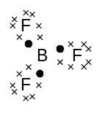  - | 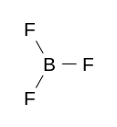 | non polar
HCO₃⁻ | 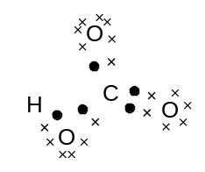 | 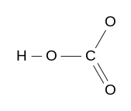 | polar
[6]
9. Corrosion of ion initiated by 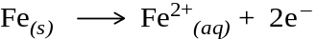 (anodic area) (1/2)
(and (cathodic area) ) (1/2)
When zinc is present the following can occur (1)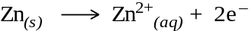
Shown on a diagram (1) (that should show flow of electrons through the iron surface)
This process has more positive reaction potential/Zn is a stronger reducing agent (1/2)
So Zn becomes the provider of electrons/the (sacrificial)anode in place of the iron so the top process will not occur so readily. (1/2)
[4]
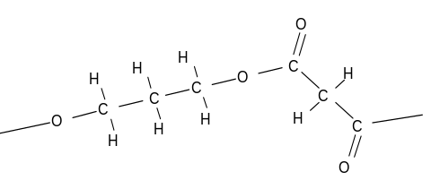10. (a)

n [2]

- Water [1]
- as a catalyst/to remove water [1]
(d) sodium/potassium dichromate/potassium permanganate and dilute (sulphuric)acid [2]
11.
 | Compounds | Test [1 mark each] | Observations [both required for 1 mark]
(a) | PbCl_{2(s)} | dissolve in water and add OH⁻/SO₄²⁻ to solution formed. | precipitate
(a) | KCl_{(s)} | dissolve in water and add OH⁻/SO₄²⁻ to solution formed. | no precipitate
(b) | CH₃CO₂C₂H₅ | Add carbonate or  use indicator | no fizzing indicator = neutral
(b) | C₃H₇CO₂H | Add carbonate or  use indicator | fizzing indicator = acidic
(c) | 1-pentanol | Add acidified dichromate or permanganate | colour change: orange to green  or purple to colourless
(c) | 2-ethyl-2-propanol | Add acidified dichromate or permanganate | no visible change
[6]

Part 3
1 (a)
Burette readings (mL) | Titrations
Burette readings (mL) | 1 | 2 | 3 | 4
Final volume | 6.50 | 11.40 | 17.25 | 23.25
Initial volume | 0.00 | 5.50 | 11.30 | 17.25
Titre | 6.50 | 5.90 | 5.95 | 6.00
Average volume = (5.90 + 5.95 + 6.00) / 3 = 5.95 mL = 5.95 x 10⁻³ L [2]
(b) n(NaOH) = cV = 0.100 x 5.9 x 10⁻³ = 5.95 x 10⁻⁴ mol
n(H⁺) = n(NaOH) = 5.95 x 10⁻⁴ mol
V(acid) = 5.00 mL = 5.00 x 10⁻³ L
c(H⁺) = n/V = 5.95 x 10⁻⁴/5.00 x 10⁻³ = 0.119 mol L⁻¹ [3]

(c) n(C₄H₆O₆) in 5mL = ½ n(H⁺) = ½ x 5.95 x 10⁻⁴ = 2.975 x 10⁻⁴ mol
M(C₄H₆O₆) = 150.088
m(C₄H₆O₆) = nM = 2.975 x 10⁻⁴ x 150.088 = 0.04465g in 5mL
m(C₄H₆O₆) in 100 mL = 0.04465 x 100/5 = 0.893 g/100mL [3]

(d) Difficulty in seeing appearance of (pink) end point [1]

2. (a) m(C) = 12.01/44.01 x 44.15 = 12.048 g
m(H) = 2.016/18.016 x 7.750 = 0.8672 g
m(O) = 17.50 – 12.048 – 0.8672 = 4.585 g

C H O
mole ratio = 12.048/12.01 0.8672 /1.008 4.585 /16.00
1.003 0.8603 0.2866
1.003/0.2866 0.8603/0.2866 0.2866/0.2866
3.50 3.00 1.00

7 6 2
empirical formula of X = C₇H₆O₂ [4]
(b) n(Cr₂O₇²⁻) = cV = 0.500 x 0.04488
= 0.02244 mol
n(Y)= 3 x n(Cr₂O₇²⁻) = 3 x 0.02244 = 0.06732 mol
M(Y) = m/n = 4.99/0.06732 = 74.1 [3]
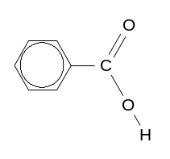
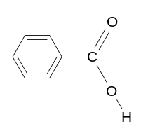
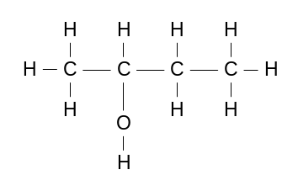
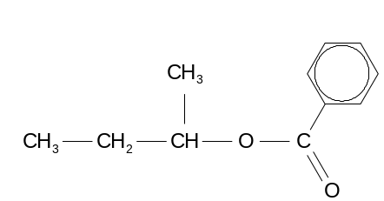
(c) X or: Y
[2]

(d)

methylpropyl benzoate
(accept butyl benzoate) [2]

3. (a) n(Cr) = 2.50/52.00 = 0.0481 mol
n(e⁻) = (12/2) x n(Cr) = 6 x 0.0481 = 0.2885 mol
Q = n x 96 500 = 27836.5 C
t = Q/I = 27836.5/2.50 = 11134.6 s = 186 minutes [4]
(b) original pH = 2.00 pH = -log[H⁺] ∴[H⁺] = inv log (- pH)
original[H⁺] = inv log (- 2.00) = 0.01 mol L⁻¹
original n(H⁺) = cV = 0.01x 5.00 = 0.0500 mol
n(H⁺)used = n(Cr) = 0.0481 mol
n(H⁺) remaining = original n(H⁺) - n(H⁺)used
= 0.0500 - 0.0481 = 1.9 x 10⁻³ mol
final[H⁺] = n/V = 1.9 x 10⁻³/5.00 = 3.8 x 10⁻⁴ mol L⁻¹ pH = -log(3.8 x 10⁻⁴) = 3.42 [4]
(c) n(Na₂Cr₂O₇) = ½ x n(Cr)
= ½ x 0.0481 = 0.02405
m(Na₂Cr₂O₇) = nM = 0.02405 x 261.98 = 6.30g [3]
(d) Chromium would react with acidic electrolyte. [1]

- (a) Standardisation:

n(H₂C₂O₄) = cV = 0.200 x 0.02907 = 5.814 x 10⁻³ mol
n(MnO₄⁻) = 2/5 x n(H₂C₂O₄)
= 2/5 x 5.814 x 10⁻³ = 2.326 x 10⁻³ mol
c(MnO₄⁻)= n/V = 2.326 x 10⁻³/ 0.02215 = 0.105 mol L⁻¹ [4]
- Titration:
n(MnO₄⁻) = cV = 0.105 x 0.00737
= 7.7385 x 10⁻⁴ mol
n(Fe²⁺) = 5 x n(MnO₄⁻) = 5 x 7.7385 x 10⁻⁴
= 3.869 x 10⁻³mol (in 20 mL sample)
total n(Fe²⁺) = (250/20) x 3.869 x 10⁻³ = 0.04837 mol [4]
(c) n(FeSO₄) = 0.04837 mol
m(FeSO₄) = nM = 0.04837 x 151.92 = 7.347g
m(H₂O) = 13.45 - 7.347 = 6.10 g

Fe SO₄ H₂O
m 7.347g 6.10g
n 7.347/151.92 6.10/18.016
= 0.04837 = 0.3386
ratio 0.04837/ 0.04837 0.3386/0.04837
1 : 7
x = 7 [4]
5. (a) m(C₈H₁₈)= 45.0 x 92/100 = 41.4 g
m(C₄H₁₀)= 45.0 x 8/100 = 3.6 g [1]
(b) n(C₈H₁₈) = m/M = 41.4/114.224 = 0.3624 mol (1/2)
n(O₂) = (25/2) x 0.3624 = 4.530 mol (1/2)
n(C₇H₁₆) = m/M = 3.6/100.198 = 0.0359 mol (1/2)
n(O₂) = 11 x 0.0359 = 0.3952 mol (1/2)
total n(O₂) used = 4.530 + 0.3952 = 4.925 mol (1)
using PV=nRT
original n(O₂) = PV/RT= (100 x 130) / (8.315 x 298) = 5.246 mol (1/2)
moles remaining = 5.246 - 4.925 = 0.321 mol (1)
volume remaining = 22.41 x 0.321 = 7.20 L (1/2) [5]

Part 4 Guidelines for marking.

1. 5 marks for each concept: should be explained with diagrams and equations as appropriate.

Aluminium Extraction Possible Other Examples
- Amphoteric nature: Ability to react with acids or bases as shown by:

ability of Al(OH)₃ to dissolve in NaOH Reaction of amphoteric metals with equation for above process: hydroxides.
Used to distinguish between required to allow filtration of impurities metals/metal compounds also show reaction of Al(OH)₃ with acid

- Complex ion: An ion where the co-ordination number of the metal atom is greater than the oxidation number/An ion with ligands around a central atom held with dative covalent bonds. As shown by:

aluminate ion [Al(OH)₄]⁻ [Cu(NH₃)₄]²⁺ in identification
(allows separation from impurities) Plumbate/stannate ions
or: [AlF₆]³⁻ ion in cryolite [Fe(CN)₆]³⁻ used to test for Fe²⁺
draw diagram to show bonding [Au(CN)₂]⁻ ased in extraction of gold

(c) Precipitation The formation of an insoluble solid in a solution as shown by:

ppt. of Al₂O₃ by seeding with Al(OH)₃ tests for sulphates/chlorides
explain how this process works must show (ionic) equations

(d) Electrolytic Reduction The reduction of positive ions to an element at the cathode of an electrolytic cell caused by electrons passing round a circuit with an external voltage applied as shown by:

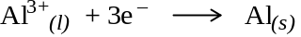 production of Au/Na etc.
explanation of process purification of Cu etc.
basic diagram of set up 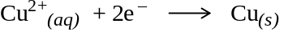
explain use of the process with diagram
2. 1. Ammonia Oxidation [approx. 7 marks]

1:9 ammonia/air mixture required to give 4:5 NH₃:O₂ ratio
Exothermic reaction so lower temperatures favour maximum yield
Catalyst used (high activation energy of uncatalysed reaction).
Catalyst functions best at higher temperature for forward reaction.
Temperature of 1380 ºC to 1470ºC temperature a compromise between yield and rate.
Surface area of catalyst maximised by fine wire.

2. Nitric Oxide Oxidation [approx. 5 marks]

Low temperature used so exothermic reaction
High pressure used as reaction:
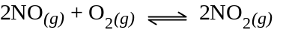
Produces 2 moles of gas from 3 moles of gas
No catalyst (not suitable catalyst or other explanation)
Slow reaction: high activation energy?

3. Absorption [approx. 5 marks]

NO produced is re-oxidised to form NO₂.
This reduces concentration of product and increases concentration of reactant so forward reaction is preferred
By removing the NO from the nitric acid the reverse reaction is reduced.
Water is still present as nitric acid is 30% to 70% (yield low).
high temperature required, (steam) otherwise reaction is too slow.
4. High-Strength Nitric Acid Production [approx. 3 marks]

Hydrogen bonding between H₂O and HNO₃ (show by diagram).
Dehydrating agent removes water therefore allows more nitric acid to be produced.
Possible comparison of H₂O - HNO₃ and H₂O - H₂SO₄ intermolecular attractions.

